The Association Between Social Media Use and Tanning

Public Health 490KR

Spring 2018

Thao Le, Rachel Duggan, Emily Lynch, Allison Pelletier

**Objective**

A survey was conducted in order to evaluate the correlation between social media use and tanning among college students. A hypothesis that college students who use social media more are more likely to go tanning, was created based on previous knowledge of how social pressures can lead to unhealthy behaviors. Social media is one of, if not the biggest platform for social influence, both negative and positive, and it should be considered when understanding what drives young people to tan, even when they have knowledge about its risk factors. Looking further into this research question we will look at race, skin type, hours on social media, types of social media used and their knowledge of tanning exposure.

**Background/Context**

# According to a 2006 study, Frequent Tanning Bed Use, Weight Concerns, and Other Health Risk Behaviors in Adolescent Females (United States),adolescent females who reported using tanning beds 10 or more times in the past year were more likely than non-tanning bed users to be concerned about their weight and to have dieted to lose weight. (O’Riordan, 2006) At the time of this study, relatively little research had been conducted to examine the association between tanning and other risky behaviors, such as binge drinking, smoking and the use of recreational drugs. However, this study points out that peer and social pressures may have an influence on risky behaviors. Tanning bed use is a risky behavior that can be influenced by peers and by unrealistic images seen in the media. Today, social media is a constant outlet where young individuals can compare themselves to others, which influences how people perceive themselves and their body image. For some people, tanning is used to feel more confident, even when the health risks that come along with tanning are known. The association between tanning use and social media should be evaluated in order to fully grasp how social pressures influence unhealthy behaviors, especially those that can cause serious non-communicable diseases.

**Methods**

The target population of our study was college students ranging from ages 18-25 living in the Amherst area, attending the University of Massachusetts Amherst. A descriptive research method was used to collect our data; a survey was carried out to collect our evidence. Our data outcome was 87 participants.

The data that was collected was transferred to an excel spreadsheet and then imported into the statistical program called Stata. After the data was imported, it was cleaned and organized so that analysis of the data would be more accurate. In order to clean the data it was necessary to define all of the variables in the dataset by labeling them and their values. Each variable was given a name that reflected the question content that it corresponded to. Labeling the variables and their values was very challenging, for it was unclear at first how to destring the variables in Stata. This was a set back in the analysis process of this project.

**Results**

From our data we found that on average most people use social media for around 3-4 hours a day with 1-2 hours following right behind.

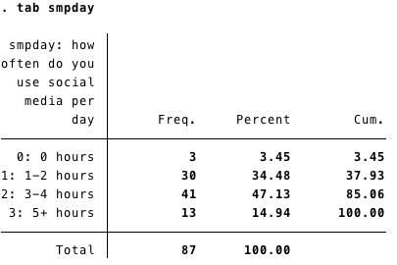

The results from our chi-square test reported a p value of .055 so we fail to reject the null and it is not statistically significant that the amount of time on social media contributes to if you have ever gone or currently go tanning.

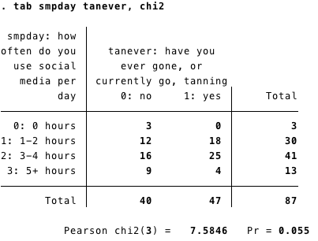

We found that, though there was mostly variation amongst how often you visited the different social media platforms, the difference in how often you visited pinterest was different whether you had gone, or currently go, tanning or not. Our chi square test resulted in a p value of (0.001) meaning we can reject the null hypothesis, indicating a statistically significant difference between these groups.

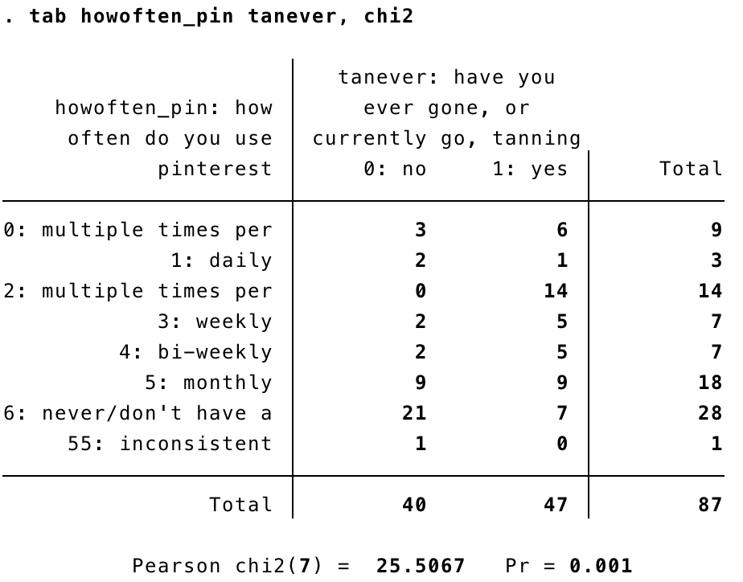

When testing for the association between how often you visit pinterest and whether you have gone tanning or currently go, we found odds ratio of (0.1667) for never visiting pinterest with confidence intervals from (0.028 to 0.989). This indicates a statistically significant association between how often you visit pinterest (never) and whether you have gone, or currently go, tanning. The odds of you never visiting pinterest are 16% lower if you have gone, or currently go, tanning compared to if you never go tanning.

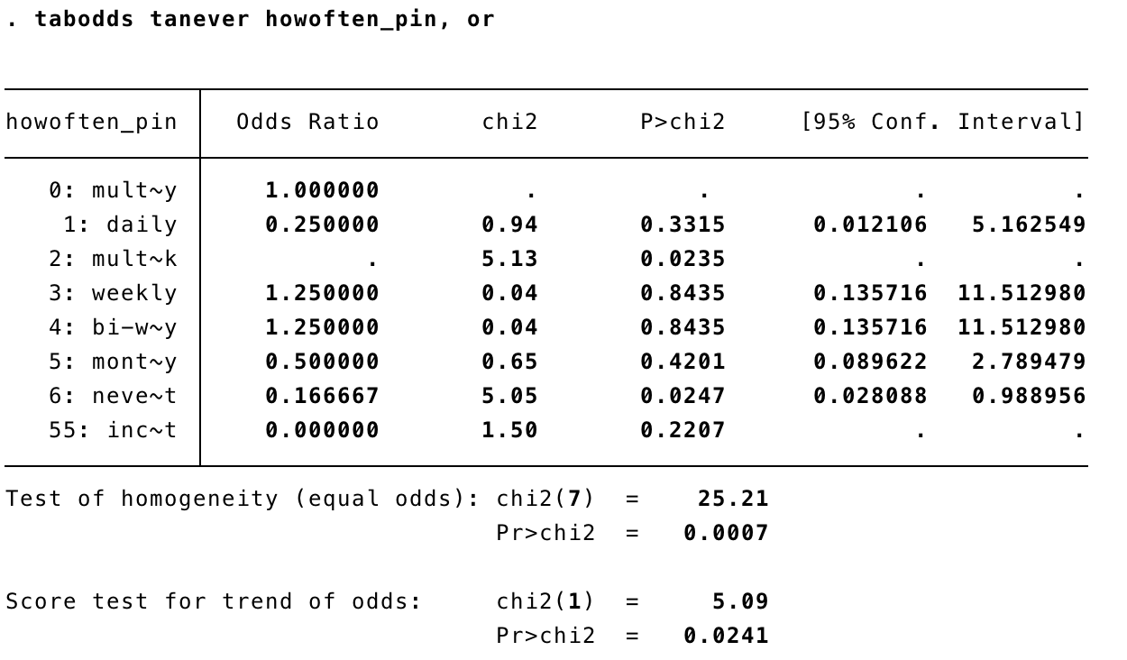

The data showed that, for most people, social media had a negative impact on their body image, with the second largest group of people feeling indifferent about it’s impact.

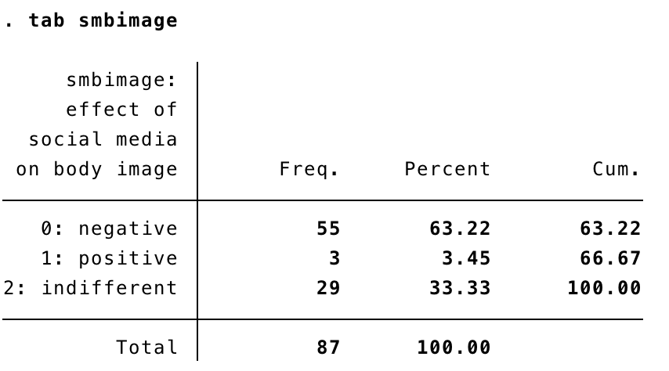

We performed a chi square test between how you feel social media has impacted your body image and whether you like the idea of tanning, and found a p value 0.043. Since this p value is low than the level of significance, we can reject the null hypothesis, indicating a statistical difference in the way social media impacts your body image and whether you like the idea of tanning.

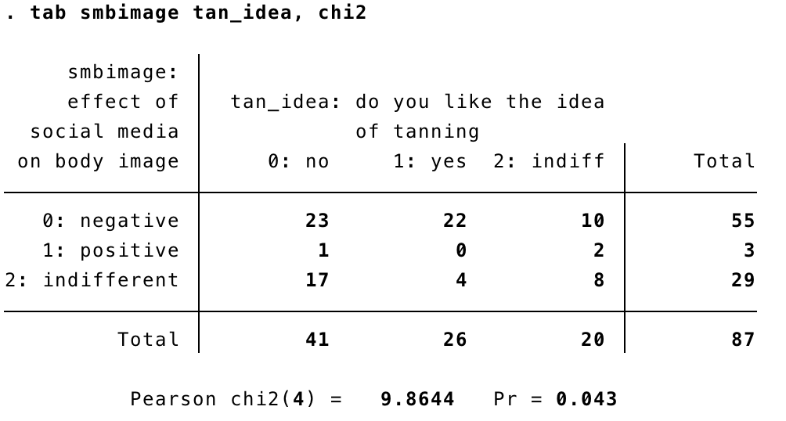

When testing for the association between whether you have gone, or currently go, tanning and how social media impacts your body image, we found an odds ratio of (0.219) for feeling indifferent towards the impact social media has on your body image, with confidence intervals from (0.078 to 0.617). This indicates a statistically significant association between whether you have gone, or currently go, tanning and not letting social media impact your body image. The odds of you feeling indifferent towards the way social media impacts your body image, compared to feeling it negatively impacts your body image, is 21.9% lower in people that have gone tanning or currently go, compared to those that do not go at all; this indicates a negative association between social media use, it’s effects on body image, and tanning.

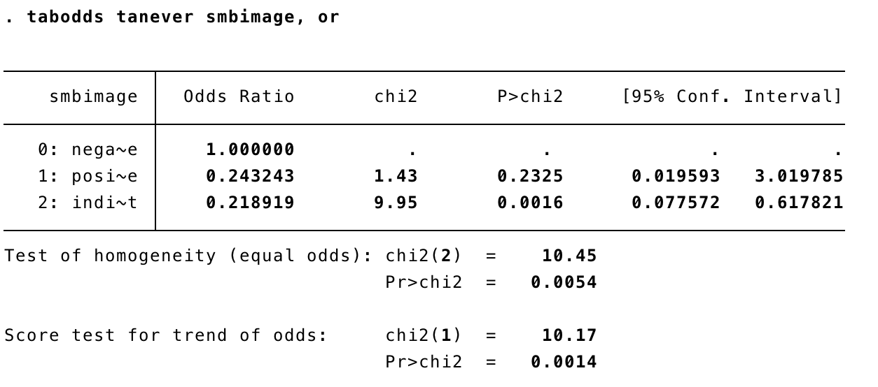

We also found that the odds of you feeling social media has influenced you to change your appearance is 6.11% times higher if you consider yourself an avid social media user, compared to those that do not. Since the odds ratio is (6.11) and the confidence intervals are (1.347 to 27.717), this indicates a statistically significant association between using social media and wanting to change your appearance because of it.

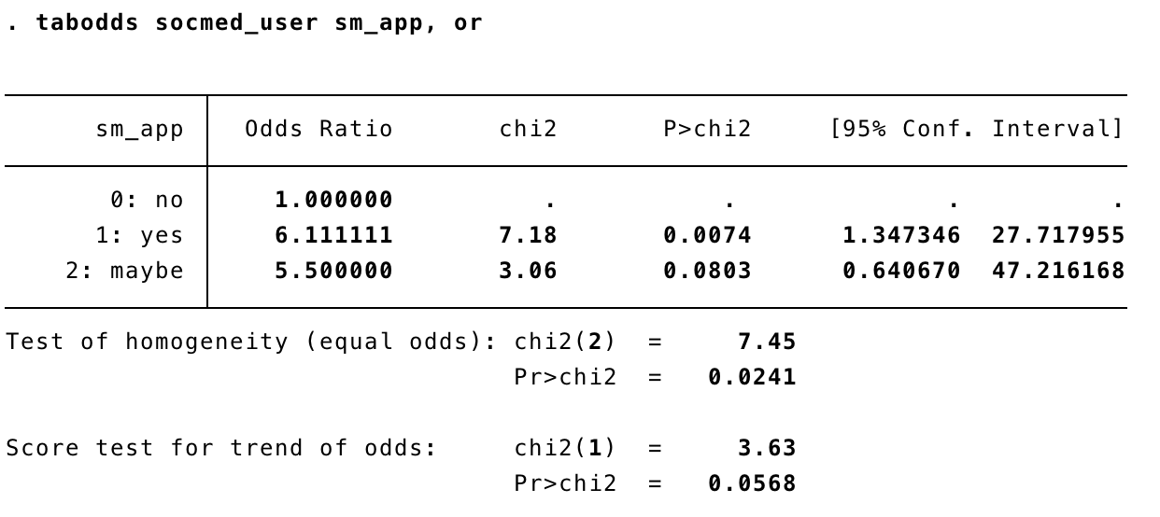

We concluded for relative risk that someone who currently tans/has gone tanning are 2 times more likely to consider themselves attractive when tan than those who do not tan so this was statistically significant because there is a positive association.

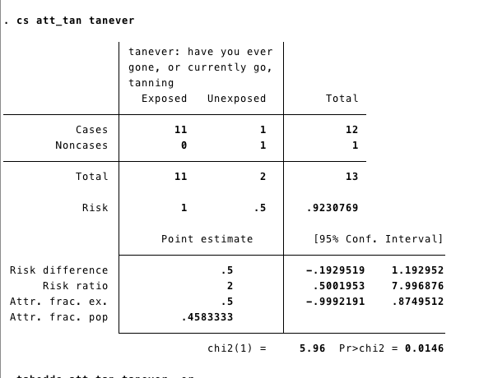

We found that the relative risk for someone who considers themselves more attractive when tan was .91 times more likely to believe they were an avid social media user and because this is below 1 this is not significant and would be considered a negative association.

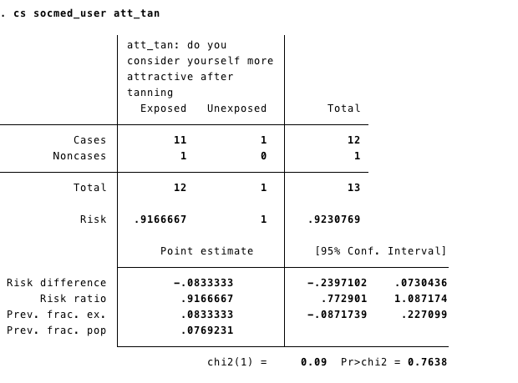

We found that the relative risk for someone who believe social media has made them want to change their appearance was .9 times more to think they are more attractive when tan because this is below 1 this is not significant and would be considered a negative association.

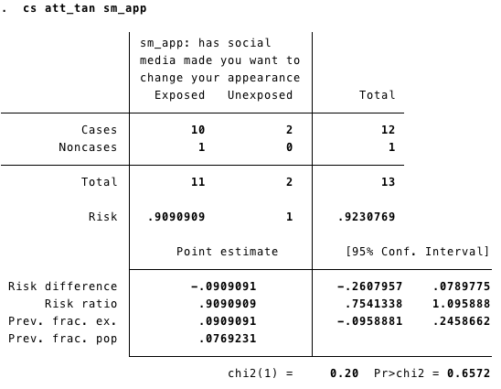

**Discussion/Limitations**

There are many limitations to our study. Although we are looking at UMass students, and in this area we have all 4 different seasons, some of these students may come from different parts of the country. It is hypothesized that those who live more to the coast are more likely to tan outside than in a tanning bed, which could skew our data. Thus, another question that could have been benefited our research was what part of the country are they from - West Coast ( California, Arizona, Nevada ) East Coast ( Mass, NY, NJ ) , Northern ( ND, SD, Ohio ) , MidWest ( Kentucky ) and Southern ( TX, FL, MS). Additionally, while going through our survey results, we realized we made the question “Employment Status: Are you currently…?” without the option to select more than one box. This made participants chose one box over the over, while they could have fallen into more than one category, for example some people are students and work part time. The purpose for this question was to see if there was a difference in those who work or don’t work, due to the financial commitment of going tanning.

Recall bias is another potential problem of our survey, for it might be harder for some people to remember their history of tanning from 5 years ago vs. within the last year. There is also a possibility of selection bias in our survey results. The respondents of our survey were people that we knew that go to UMass. All of our group members were female and sent the survey out to mostly female participants, so we were unable to accurately get a representative sample of the general population of the UMass Campus.

Lastly, it is important to recognize different cultural standards of beauty while analyzing this data. In our hypothesis we assume that social media has a negative effect on some people’s self esteem or beauty standards, which causes them to go tanning. However, tan is not the beauty standard for everyone. The majority of our participants were white and those were the people that were most likely to go tanning. Another portion of our respondents were Asian and were less likely to tan. This may be due to Asian beauty standards of being tan being attractive and pale as being pretty. Making assumptions about what our outcomes were going to be may have influenced the way we designed certain questions on the survey.

**Conclusion**

After analyzing our results, it does not appear that social media effects tanning. However, our data suggests that there are statistically significant associations between social media use and how people view their body image, including wanting to change their appearance (the odds of you feeling social media has influenced you to change your appearance is 6.11% times higher if you consider yourself an avid social media user, compared to those that do not.) More research should be conducted that examines how social media impacts self image that may lead to risky behaviors, specifically tanning.

**Appendix**

1. A link to the questionnaire: <https://docs.google.com/forms/d/e/1FAIpQLSfw_hk2z4aL6dt1NRX5USm0De2XB15fKYXmU9eBpPuWvzGgGg/viewform?usp=sf_link>
2. A codebook for the dataset

<https://docs.google.com/spreadsheets/u/1/d/e/2PACX-1vQ-5gJ8wHgcd-fENXPLH5Mz5Qomz0YllOqcBPEWRsiZrEaENvr9izztZAuj7LZMFgMbfeofjat7527P/pubhtml>

1. A copy of the final Stata program